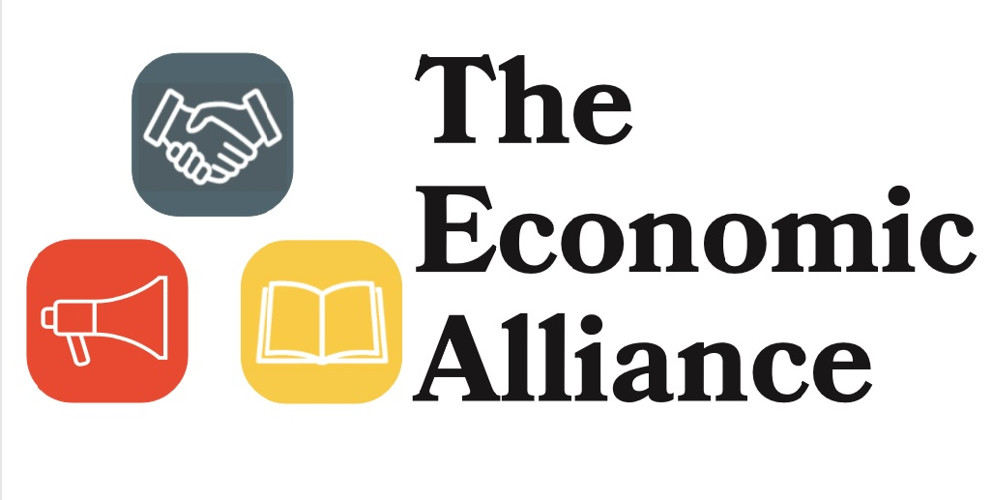

Strategic Plan
June 2018

Vision: To make our communities the best place to do business.

Mission: To give a voice to the economic and business interests of Wadena County and surrounding communities by providing educational, networking, and advocacy resources and opportunities.

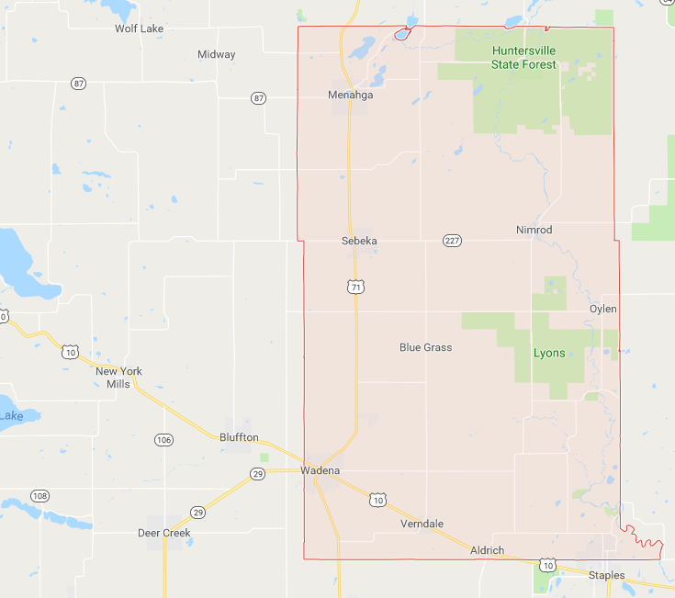

The Economic Alliance current service area—Wadena County, MN and the City of New York Mills, MN

Executive Summary
The Economic Alliance (the Alliance) was formed as a private, not-for-profit in 2011 from the need for a voice for economic development in West Central Minnesota. With the goal of collaboration and flexibility in mind, the Alliance was organized to represent both public and private interests and not to be confined to a defined governmental boundary. Today, the Alliance consists of an Executive Board of volunteers representing banking, government, non-profit, and private industry interests and a full-time Executive Director who carries out the day-to-day operations and strategic mission of the Alliance. The Alliance currently serves all of Wadena County and the City of New York Mills.

This plan is designed to provide a roadmap for the activities of the Alliance. It contains a description of the three pillars of the Alliance—education, networking, and advocacy—as well as priorities and strategies for implementation. The foundation of this strategic plan is input from community and business leaders. It was their dreams and concerns for the region that shaped and guided this document and will continue to shape and guide the Alliance for years to come.

The Pillars of the Economic Alliance
The pillars derive from the mission of the Alliance, which is, “To give a voice to the economic and business interests of Wadena County and surrounding communities by providing educational, networking, and advocacy resources and opportunities.” The purpose of these pillars is to provide a foundation for all the activities of the Alliance. They are designed to be adaptable to different projects and objectives as community needs and trends change.
Education

The purpose of this pillar is for the Alliance to provide training and resources on topics that are crucial for business and regional success.
Tools for implementation include, but are not limited to:
- Communication and Public Relations—including the Alliance website, social media accounts, press releases, marketing campaigns, newsletters, etc.
- Facilitating and promoting classes, events, etc., with the purpose of providing information on topics pertinent to businesses and the community
- 1:1 consultation with entrepreneurs and business owners

Networking

The purpose of this pillar is for the Alliance to connect business and community members to share ideas and solve problems.
Tools for implementation include, but are not limited to:
- The Alliance participation in the community
- Facilitating collaboration between civic and business members to promote engagement and seek solutions for collective issues
Advocacy

The purpose of this pillar is for the Alliance to serve as a voice at the regional, state, and federal level for the economic interests of Wadena County and surrounding communities.
Tools for implementation include, but are not limited to:
- Grant writing
- Responding to Requests for Information from prospective businesses
- Participating in the legislative process
- Communication and Public Relations—including the Alliance website, social media accounts, press release, marketing campaigns, newsletters, etc.

Priorities and Strategies for Implementation
The following priorities and strategies are representative of the needs and concerns that exist in the community as of Spring 2018. This is designed to be a living document—as our community develops and changes, so will these priorities. It is our hope, however, that our focus and dedication to these topics will be a driving force to that development and change.

Priority 1: Business Start-Up, Retention, and Expansion
The Alliance has a vested interest in attracting and retaining businesses in our communities. The following strategies are aimed at achieving that goal.
Strategy A: Develop a relationship with entrepreneurs and business owners
- Become a contributing member of existing groups whose purpose is to attract and retain local businesses, such as BR&E, C&Cs, EDAs, etc.
- Perform regular “check ins” with businesses to evaluate their needs and determine how the Alliance may be able to assist
- Conduct business retention and expansion surveys to understand their changing needs
Strategy B: Provide the tools and resources necessary to help businesses grow and develop
- Provide business planning consultation, in collaboration with other agencies who will aid with the financial aspects of the plans
- Develop our website into a tool that can be used to help businesses grow and develop
- Offer in-person training and informational sessions on topics pertinent to business development and success
Strategy C: Encourage entrepreneurialism
- Facilitate informational sessions and events focused on entrepreneurialism and business planning
- Develop a mentor network to connect aspiring entrepreneurs with existing and/or retired business owners
- Work with area resources (i.e. schools, community groups, etc.) to host events/activities that promote entrepreneurialism
Strategy D: Promote the region to outside entities
- Respond to Requests for Information from prospective businesses as appropriate
- Provide quality, attractive information about our community online by updating our own websites and social media accounts and contributing content to regional promotional sites as appropriate

Priority 2: Infrastructure Improvement
The infrastructure in a community, including housing and commercial lots and buildings, is key to attracting and retaining both businesses and their needed workforce. The following strategies are aimed at developing a community infrastructure that is attractive to business owners and community members alike.
Strategy A: Update and promote housing options
- Work with cities who have lots/houses available for sale to develop a strategic marketing plan so that they can be sold
- Promote grant/loan options available to home owners to address existing slum and blight issues
- Facilitate collaboration between civic and businesses leaders to discuss how to best improve housing stock.
Strategy B: Be an advocate for downtown and commercial revitalization
- Provide information on existing commercial buildings/lots for sale on our website
- Become knowledgeable on commercial rehabilitation and improvement options—including grants, historical designations, best practices, etc.—and pursue as appropriate
- Become knowledgeable on Brownfield grants and other demolition options and pursue as appropriate
- Be an advocate for economic interests in city and county strategic and comprehensive planning efforts
Strategy C: Be an advocate for economic interests in city and county strategic and comprehensive planning efforts

Priority 3: Workforce Development
Having an active workforce is the backbone of economic development. Without qualified applicants to fill positions, businesses cannot grow and develop. The following strategies are aimed at retaining, promoting, and attracting workers to our region.
Strategy A: Prepare our future workforce to meet the region’s needs
- Enhance collaboration between employers, students, parents, and schools for shared understanding of workforce needs and opportunities
- Sponsor events that encourage entrepreneurialism at the high school and college level
Strategy B: Enhance the region’s image in order to attract outside job seekers
- Collaborate with, improve upon, and promote use of regional recruitment tools, such as the Good Life
- Facilitate collaboration between recruitment professionals
Strategy C: Assess and analyze gaps between labor supply and demand
- Strengthen connections with Minnesota State Colleges and Universities to gain access to recruitment and training opportunities
- Identify barriers to workforce retention and recruitment and collaborate with regional partners to seek solutions (i.e. daycare issues)

